B.M.S COLLEGE OF ENGINEERING BENGALURU
Autonomous Institute, Affiliated to VTU



SPC AAT Report on

Casino Simulator

Submitted in partial fulfillment of the requirements for AAT

Bachelor of Engineering
in
Computer Science and Engineering

Submitted by:

Aditi Khare

Aaisha Yadav

Department of Computer Science and Engineering
B.M.S College of Engineering
Bull Temple Road, Basavanagudi, Bangalore 560 019
2025-2026

B.M.S COLLEGE OF ENGINEERING
DEPARTMENT OF COMPUTER SCIENCE AND ENGINEERING



DECLARATION

We, AAAA students of 1st Semester, B.E, Department of AIML , BMS College of Engineering, Bangalore, hereby declare that, this AAT Project entitled "CASINO SIMULATOR" has been carried out in Department of CSE, BMS College of Engineering, Bangalore during the academic semester Oct 2024 – Jan 2025. We also declare that to the best of our knowledge and belief, the AAT Project report is not from part of any other report by any other students.

Student Name Student Signature
1. Aditi Khare
2. Aaisha Yadav

BMS COLLEGE OF ENGINEERING
DEPARTMENT OF COMPUTER SCIENCE AND ENGINEERING

CERTIFICATE

This is to certify that the AAT Project titled “CASINO SIMLATOR” has been carried out by Aditi khare (1BM25AI281-T) and Aaisha Yadav (1BM25AI303-T) during the academic year 2025-2026.

Signature of the Faculty in Charge

Table of Contents
Sl. No. | Title | Page no.
1 | Introduction | 1
2 | Algorithm | 2
3 | Flowchart | 3
4 | Source code | 4-5
5 | Results (screenshots) | 6
6 | References | 7

1. INTRODUCTION

This simulator mimics the core loop of a real-world casino game: the buy-in, the wager, the house edge, and the payout. It provides a safe environment to explore how probability and bankroll management work in software development.

Core Mechanics

The Bankroll: The player starts with a fixed "wallet" of 1,000 units. The game persists as long as the player remains solvent.

The Odds: Since the player picks 1 number out of 10, the mathematical probability of winning is $10\%$.

The Payout Structure: To keep the game exciting, the simulator offers a 5-to-1 payout. While the odds are 1 in 10, the reward is $5 \times$ the bet, which introduces a "house edge" typical of casino algorithms.

Randomization Engine: Using srand(time(NULL)), the program ensures that the "dealer" (the CPU) isn't predictable, simulating the randomness of a slot machine or a roulette wheel.

2. ALGORITHM

Step 1: Start the program.
Step 2: Initialize the player’s balance to 1000 and set the play choice to 'y'.
Step 3: Initialize the random number generator using the current time.
Step 4: While the player chooses to continue playing (play = 'y' or 'Y'), repeat the following steps:
Step 4.1: Display the current balance.
Step 4.2: Read the bet amount from the player.
Step 4.3: If the bet amount is less than or equal to zero or greater than the available balance, display an error message and return to Step 4.1.
Step 4.4: Ask the player to guess a number between 1 and 10 and read the guess.
Step 4.5: Generate a random number between 1 and 10 for the casino.
Step 4.6: Compare the player’s guess with the generated number.
• If both are equal, add five times the bet amount to the balance and display a winning message.
• Otherwise, subtract the bet amount from the balance and display a losing message.
Step 4.7: If the balance becomes zero or negative, display a “Game Over” message and exit the loop.
Step 4.8: Ask the player whether to play again and read the choice.
Step 5: Display the final balance.
Step 6: Stop the program.

3. FLOWCHART

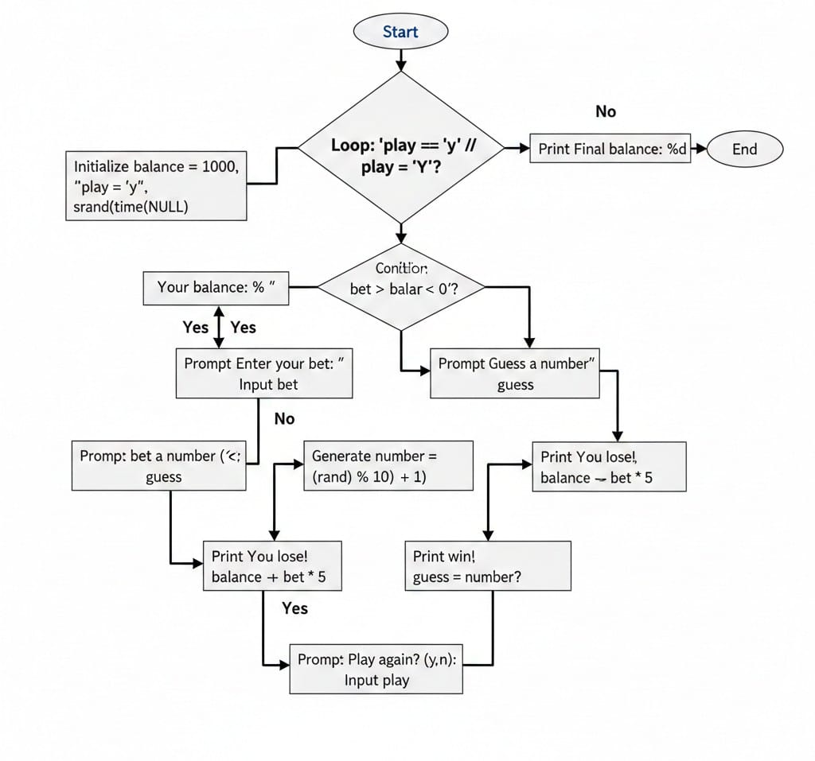

4. SOURCE CODE
#include <stdio.h>
#include <stdlib.h>
#include <time.h>

int main() {
int balance = 1000;
int bet, guess, number;
char play = 'y';

srand(time(NULL));

while (play == 'y' || play == 'Y') {
printf("\nYour balance: %d\n", balance);
printf("Enter your bet: ");
scanf("%d", &bet);

if (bet > balance || bet <= 0) {
printf("Invalid bet!\n");
continue;
}
printf("Guess a number (1-10): ");
scanf("%d", &guess);

if (guess < 1 || guess > 10) {
printf("Invalid number! Please enter a number between 1 and 10.\n");
continue;
}
number = (rand() % 10) + 1;
if (guess == number) {
printf("You win! The number was %d\n", number);
balance += bet * 5;
} else {
printf("You lose! The number was %d\n", number);
balance -= bet;
}

if (balance <= 0) {
printf("You are out of money! Game over.\n");
break;
}

printf("Play again? (y/n): ");
scanf(" %c", &play);
}

printf("\nFinal balance: %d\n", balance);
return 0;
}

5. RESULTS

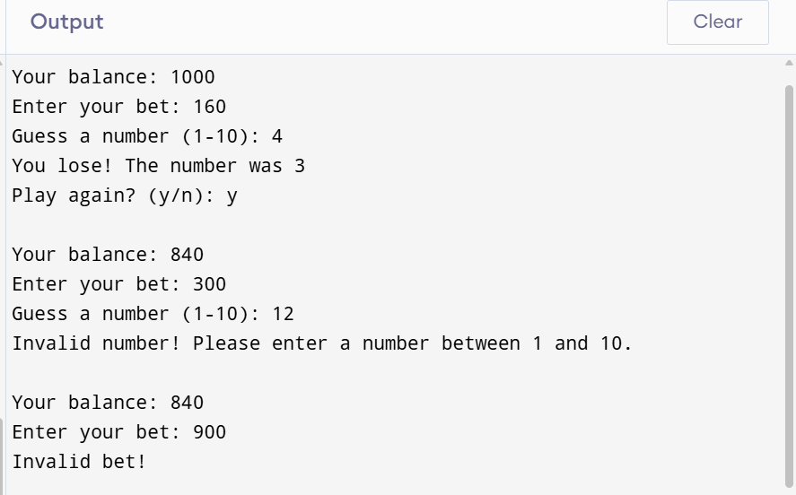

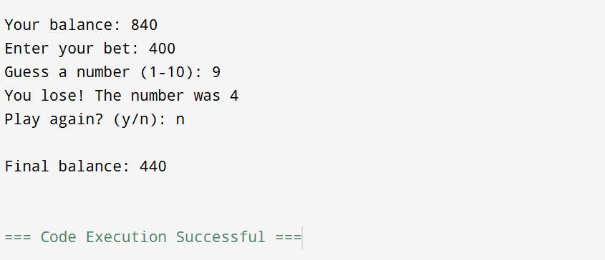

REFERENCES

- C programming absolute Beginners’s guide by Greg Perry and Dean Miller
- C programming made easy by Dennis Ritchie
- GeeksforGeeks – C Programming Language

